

Senate Resolution No. 2025/2026 - 080
In Endorsement of the Associated Students of the University of California (ASUC) Official Letter on the Proposed Changes to the Add/Drop Deadline

Primary Sponsor
Jennifer Tran (Academic Affairs Vice President)
Cosponsors
Dylan Lucks (Office of Academic Affairs External Chief of Staff), Jonathan Franco (Office of Academic Affairs Internal Chief of Staff)

WHEREAS, the Associated Students of the University of California (ASUC) Office of the Academic Affairs Vice President (OAAVP) represents the UC Berkeley undergraduate student body in matters of academic policy, campus affairs, campus culture and climate, admissions and enrollment, preparatory education, and financial aid; and,

WHEREAS, the Council of Undergraduate Deans (CUD), an advisory body to the Vice Provost of Undergraduate Education (VPUE), is the campus body charged with the review and approval of changes to the campus add/drop deadline; and,

WHEREAS, CUD has deliberated about and written a proposal, with plans of implementation in Fall 2026, to move up the Late Add/Drop Deadline from its current status at Week 4 to Week 3, and eliminate the Early Add/Drop Deadline; and,

WHEREAS, CUD invited the OAAVP to its October 30, 2025 meeting to share ASUC comments regarding the add/drop deadline; and,

WHEREAS, the OAAVP was grateful for the opportunity to share ASUC comments regarding the add/drop deadline; and,

WHEREAS, at the October 30, 2025 CUD meeting, the OAAVP presented a slide presentation (Appendix B) and memorandum (Appendix C, p. 1–5) outlining several potential changes to the undergraduate add/drop deadline and providing a balanced analysis of the arguments for earlier, later, and alternative add/drop timelines, including considerations related to student course exploration, waitlist efficiency, instructional stability, and Berkeley’s commitment to discovery-driven undergraduate education; and,

WHEREAS, the memorandum additionally summarized the results of an ASUC Closed Add/Drop Deadline Survey (Appendix C, p. 6–10) conducted by the OAAVP, which gathered testimony and ranked preferences from 25+ ASUC elected officials and senior staff representing diverse undergraduate student communities on campus and found broad opposition to moving the add/drop deadline earlier than the current timeline; and,

WHEREAS, the memorandum (Appendix C, p. 11) concluded by communicating the official position of the OAAVP in strong opposition to moving the add/drop deadline earlier, concluding that such a change would limit students’ ability to make informed enrollment decisions and could disproportionately affect students balancing academic, employment, and extracurricular commitments, while emphasizing that any policy changes should uphold Berkeley’s values of flexibility, exploration, and student success; and,

WHEREAS, after the October 30, 2025 CUD meeting, the OAAVP collaborated with CUD Chair and another CUD member on a campus-wide Add/Drop Survey (Appendix D); and,

WHEREAS, the OAAVP recommended that the suggested campus-wide survey on the add/drop deadline be incorporated into the Spring 2026 Pulse Survey in order to generate the most comprehensive and representative student data possible; and,

WHEREAS, this suggestion was declined by CUD due to the timeline the body sought to follow, which included review by the Berkeley Division of the Academic Senate (AS) in early February and a vote in March; and,

WHEREAS, CUD asked the Academic Senate for comment on its proposal to move the Late Add/Drop Deadline earlier and eliminate the Early Add/Drop Deadline in January 2026; and,

WHEREAS, the Academic Senate 2025–2026 Chair requested that the Courses of Instruction Committee (COCI) and Undergraduate Council (UGC), two Academic Senate committees, provide comment on the CUD proposal; and,

WHEREAS, both COCI and UGC include undergraduate student representatives who sit as voting members on the committees; and,

WHEREAS, at the February 4, 2026 UGC meeting, the Academic Affairs Vice President (AAVP) presented a memorandum (Appendix E) summarizing the results of a campus-wide undergraduate survey on the add/drop deadline conducted between December 2025 and January 2026 with 247 student respondents; and,

WHEREAS, the memorandum analyzed student enrollment behavior, including course drop timing and waitlist experiences (Appendix E, p. 3–8), and found that many students rely on the third and fourth weeks of instruction to evaluate workload, receive graded feedback, and determine academic fit before finalizing their schedules; and,

WHEREAS, the survey results (Appendix E, p. 3–8) further indicated overwhelming student concern, with 93.5% of students surveyed reporting at least one negative impact from an earlier add/drop deadline and indicating that such a policy change could disproportionately impact underrepresented students and those who rely on enrollment flexibility to maintain financial aid or visa-related unit requirements; and,

WHEREAS, CUD will soon review and vote on its proposal to move the Late Add/Drop Deadline earlier and eliminate the Early Add/Drop Deadline; and,

WHEREAS, the add/drop deadline directly shapes undergraduate students’ ability to explore courses, manage academic workloads, and make informed enrollment decisions during the first weeks of the semester, making any changes to this policy of significant consequence to the undergraduate student body; and,

WHEREAS, it is the responsibility of the ASUC Senate to formally represent the interests and concerns of the UC Berkeley undergraduate student body in matters of academic policy affecting their educational experience; and,

THEREFORE BE IT RESOLVED, that the Associated Students of the University of California (ASUC) formally opposes the Council of Undergraduate Deans (CUD) proposal to move the Late Add/Drop Deadline earlier in the semester and eliminate the Early Add/Drop Deadline; and,

THEREFORE BE IT FURTHER RESOLVED, that the ASUC formally endorses the attached letter (Appendix A) from the ASUC OAAVP communicating the official position of the ASUC regarding the proposed changes to the add/drop deadline; and,

THEREFORE BE IT FINALLY RESOLVED, that the ASUC directs that this letter be transmitted to the Council of Undergraduate Deans (CUD), the Vice Provost for Undergraduate Education (VPUE), and relevant administration and faculty involved in deliberations regarding the add/drop deadline policy.

Appendix A

LETTER
Associated Students of the University of California (ASUC) Official Letter on the Proposed Changes to the Add/Drop Deadline

To: Alan Karras, Chair, Council of Undergraduate Deans
Andrew Atwood, Member, Council of Undergraduate Deans
Deborah Nolan, Member, Council of Undergraduate Deans
Emma Daftary, Member, Council of Undergraduate Deans
Erin Murphy-Graham, Member, Council of Undergraduate Deans
Janelle Scott, Member, Council of Undergraduate Deans
Jill Berrick, Member, Council of Undergraduate Deans
Jonathan Marshall, Member, Council of Undergraduate Deans
Kate O’Neill, Member, Council of Undergraduate Deans
Lisa Barcellos, Member, Council of Undergraduate Deans
Oscar Dubón, Member, Council of Undergraduate Deans
Roya Maboudian, Member, Council of Undergraduate Deans
Liza Schlosser, Staff, Council of Undergraduate Deans
Sarah Reed, University Registrar, Enrollment Management
Oliver O’Reilly, Vice Provost for Undergraduate Education
Catherine Cronquist Browning, Assistant Vice Provost and Chief of Staff, Undergraduate Education
Stephen Sutton, Vice Chancellor for Student Affairs
Sunny Lee, Associate Vice Chancellor & Dean of Students
Olufemi Ogundele, Associate Vice Chancellor and Dean of Enrollment Management and Undergraduate Admissions
Mark Stacy, Chair 2025-2026, Academic Senate
Thomas Philip, Vice Chair 2025-2026, Academic Senate

From: Jennifer Tran, Academic Affairs Vice President 2025-2026, Associated Students of the University of California

March 11, 2026

Dear colleagues,
On behalf of the Associated Students of the University of California (ASUC), I write to share the official stance of the ASUC regarding the Council of Undergraduate Deans’ (CUD) proposal to move up the Late Add/Drop Deadline from Week 4 to Week 3 and eliminate the Early Add/Drop Deadline, with proposed implementation beginning in Fall 2026.
The ASUC recognizes the CUD's efforts to address longstanding student concerns related to course access, waitlists, and enrollment inefficiencies at UC Berkeley. Ensuring that students are able to enroll in the courses they need and progress toward their degrees in a timely manner is a goal the ASUC shares with CUD, Undergraduate Education (UE), and the Berkeley Division of the Academic Senate (AS). The ASUC appreciates the CUD's continued attention to these challenges and the work undertaken to explore potential policy solutions.
In forming its position on this proposal, the ASUC has relied heavily on the analysis and outreach conducted by the ASUC Office of the Academic Affairs Vice President (OAAVP), which has engaged with CUD, UE, and the AS on this issue throughout the academic year. The ASUC reviewed Senate Resolution No. 2025/2026 - 80 (Appendix A), as well as memoranda and presentations compiled by the OAAVP and presented to CUD (Appendix B and C) and the Undergraduate Council (UGC) within the AS (Appendix D and E ).
In addition to the arguments, concerns, and conclusions raised in these documents, the ASUC has several implementation questions regarding how an earlier add/drop deadline would interact with key parts of the UC Berkeley campus academic ecosystem. These include questions related to decentralized waitlist management practices across departments, advising capacity during the early weeks of the semester under the proposed changes, impacts on the financial aid census requirements, students’ capacity to continue to make unit minimums, international student enrollment regulations, and DeCal instruction and enrollment timelines. Given that these areas directly affect thousands of undergraduate students each semester, the ASUC believes that additional analysis and consultation by CUD with relevant campus units would be beneficial before implementing a policy change of this scale.
For these reasons, the ASUC respectfully requests the following.
First, that the Council of Undergraduate Deans delay consideration of the proposed changes to the add/drop deadline until the 2027–2028 academic year, to allow additional time for consultation with impacted campus units, more comprehensive quantitative analysis of student enrollment behavior, and a more rigorous evaluation of the proposal’s potential impacts on the student body as a whole and on specific student communities, including but not limited to, transfer students, student parents, international students, and decal facilitators.
Second, that any proposal to move the Late Add/Drop Deadline earlier be considered alongside complementary policy proposals designed to mitigate potential impacts on students, such as increasing the number of permitted late course drops over a student’s Berkeley career by two times (e.g. from two to four in the College of Letters & Science) and moving the Pass/No Pass (P/NP) deadline from the 10th Week of Instruction to the 12th Week of Instruction.
Third, that the ASUC Academic Affairs Vice President be included in all future discussions and deliberations by CUD regarding changes to the campus add/drop deadline or pass/no pass deadline so that undergraduate student perspectives may continue to inform the policy development process.
The ASUC remains committed to working collaboratively with the Council of Undergraduate Deans, the Division of Undergraduate Education, and campus leadership to address challenges related to course access and enrollment. We appreciate all bodies’ continued engagement with undergraduate student representatives on this issue and look forward to continued dialogue.

Sincerely,

Jennifer Tran
ASUC Academic Affairs Vice President
On behalf of the Associated Students of the University of California (ASUC)

cc: Abigail Verino, President 2025-2026, ASUC
Isha Chander, Executive Vice President 2025-2026, ASUC
Jennifer Tran, Academic Affairs Vice President 2025-2026, ASUC
Calvin Yang, External Affairs Vice President 2025-2026, ASUC
Britnee Stephen, Student Advocate 2025-2026, ASUC
Giselle Arteaga, Chief Communications Officer 2025–2026, ASUC
Jonathan Ngai, Chief Financial Officer 2025–2026, ASUC
Daniel Dolan, Chief Legal Officer 2025–2026, ASUC
Shelby Coleman, Chief Personnel Officer 2025–2026, ASUC
Shlok Sooch, Chief Technology Officer 2025–2026, ASUC
Anamaria Abnusy, Senator 2025–2026, ASUC
Somer Alrai, Senator 2025–2026, ASUC
Colton Beardsley, Senator 2025–2026, ASUC
Abigail Cho, Senator 2025–2026, ASUC
Talia Golshani, Senator 2025–2026, ASUC
Reg Macarro, Senator 2025–2026, ASUC
Abdullah Memon, Senator 2025–2026, ASUC
Selina Mendez, Senator 2025–2026, ASUC
Nicole Nunez-Rivera, Senator 2025–2026, ASUC
Ayden Reading, Senator 2025–2026, ASUC
Shawn Ree, Senator 2025–2026, ASUC
Kianna Rodarte, Senator 2025–2026, ASUC
Bella Santos, Senator 2025–2026, ASUC
Sydney Scott, Senator 2025–2026, ASUC
Margaret Solomon, Senator 2025–2026, ASUC
Lucia Stankovic, Senator 2025–2026, ASUC
Sara Teran, Senator 2025–2026, ASUC
Sydnee Thy, Senator 2025–2026, ASUC
Rayne Xue, Senator 2025–2026, ASUC
Jada Yang, Senator 2025–2026, ASUC
Joshua De Miguel, Transfer Representative 2025-2026, ASUC

Appendix B
Presentation to Council of Undergraduate Deans on the Add/Drop Deadline
Presentation link: Council of Undergraduate Deans Add/Drop Deadline Presentation

Appendix C
MEMORANDUM
Proposed Changes to Undergraduate Add/Drop Deadlines

ASUC Office of Academic Affairs
Jennifer, ASUC Academic Affairs Vice President (aavp@asuc.org)
Dylan Lucks, Chief of Staff (aavpchief@asuc.org)
Jonathan Franco, Chief of Staff (aavpchief@asuc.org)

To: Council of Undergraduate Deans October 30, 2025

Overview
In recent headlines, UC Berkeley’s recognition as the #1 Public University reaffirms what our community has long known—that Berkeley’s strength lies not only in academic rigor, but in its enduring commitment to access, discovery, and public impact. As Chancellor Rich Lyons noted in response to this distinction, “the data affirm all that Berkeley does as a powerful engine of economic mobility, and provider of affordable world-class education, accessible to all.”
Undoubtedly, Berkeley’s distinctive approach to undergraduate education—grounded in a culture of accessible discovery that empowers our students, faculty, and staff to create public impact—stands as a defining element of its world-class education. UC Berkeley’s culture of discovery is not accidental. Discovery is embodied by our campus’ undergraduate students because it is made possible by Berkeley’s institutional structures that encourage intellectual curiosity. The undergraduate add/drop policy plays a crucial role in this process, enabling students to explore courses, calibrate workloads, and pursue new ideas without fear of early missteps.
As the UC Berkeley campus evaluates potential changes to the add/drop timeline, it is important to consider how such adjustments may either enhance or constrain students’ ability to engage in this core aspect of Berkeley’s educational philosophy.
Furthermore, it is essential that student voices not only be consulted but actively guide any changes to the add/drop deadline. Undergraduate students are directly affected by this policy, as course enrollment decisions intersect with a wide range of personal, academic, and financial considerations. Beyond the classroom, students often balance part-time employment, research commitments, housing or transportation challenges, financial aid requirements, and responsibilities to family or community. These factors shape when and how students make final decisions about their course schedules.
Listening to and prioritizing student perspectives ensures that policy decisions reflect the realities of the undergraduate experience—not only the administrative or logistical efficiencies of the enrollment system. Meaningful student input is therefore necessary to ensure that changes to the add/drop timeline uphold Berkeley’s commitment to equity, inclusion, and student success.

Add/Drop Deadline Proposals
The Office of Academic Affairs discussed many different add/drop deadline proposals and references them throughout this memo as “Add/Drop Deadline Proposal 1-6,” including:

Early Add/Drop Deadline: Set the second week of instruction as the Early Add and Drop Deadline, and move up the late Add/Drop Deadline to earlier than the fourth week of instruction.

Add/Drop/Grade Change Cap: Permanently increase the cap for late change of schedule actions (class drops or grade-based changes after the deadline) substantially, from one/two actions to four to six actions over a student’s time at Berkeley

Status Quo: Keep the Early Add/Drop deadline at the second week of instruction and the Late Add/Drop deadline at the fourth week of instruction.

Decouple the Add/Drop deadline, Later Add Deadline: Set the second week of instruction as the Early Add and Drop Deadline, the fourth week of instruction as the Late Drop Deadline, and later than the fourth week of instruction as the Add Deadline.

Decouple the Add/Drop deadline, Later Drop Deadline: Set the second week of instruction as the Early Add and Drop Deadline, the fourth week of instruction as the Late Add Deadline, and later than the fourth week of instruction as the Drop Deadline.

Extend the Add/Drop deadline: Keep the Early Add/Drop deadline in the second week of instruction and extend the late Add/Drop deadline to the fifth week of instruction or later.

History of the Add/Drop Deadline
Prior to Fall 2005, the add/drop deadline was at the end of the eighth week of instruction. Beginning in Fall 2005, the deadline was moved to the end of the fifth week of instruction, and an early add/drop deadline in the second week of instruction was added for high-demand and high-attrition rate classes. More than a decade later, in 2018, the campus decided to move the add/drop deadline again, this time to the end of the fourth week of instruction. The primary motivation behind the change was to enroll waitlisted students more quickly; however, the proposal was met with opposition from the ASUC.

Arguments for an Earlier Add/Drop Deadline

The Undergraduate Perspective
An earlier add/drop deadline would require students to finalize their course schedules sooner, likely within the first two-three weeks of instruction (Aligned with Add/Drop Deadline Proposal 1). Forcing students to finalize their course schedules earlier could provide students with more stability in their coursework at the beginning of the semester by effectively reducing the amount of time students have to “shop” for courses. This stability would allow students to begin coursework, form study groups, and engage with class material earlier in the term without the disruptions that occur when peers are added or dropped from their courses late into the term.
An earlier add/drop deadline also helps to prevent courses from concluding with unfilled seats. Under the current system, seats dropped by students during the fourth week of instruction are unlikely to be filled if there are no students on the waitlist that have already committed time and effort into the course while not officially enrolled. In a DailyCal article published on October 9, 2025, Vice Provost for Undergraduate Education Oliver O’Reilly noted that “by the time some enrolled students drop a course, it’s often too late for other students to enroll, leaving seats unfilled and delaying or preventing students from getting the classes they need.”
Finally, an earlier deadline may help reduce the number of students on waitlists. For the waitlisted students, earlier add/drop deadline (Proposal 1) or a decoupled add/drop deadline with a later add deadline (Proposal 4) provides increased clarity on their chances of enrolling, enabling them to pivot to alternative options earlier in the semester if enrollment off the waitlist does not seem possible. Earlier deadlines make waitlists resolve more efficiently and reduce the number of students left waiting or attending unofficially into week three or four of the term.

The Faculty Perspective
Students understand the impact of the add/drop deadline on faculty alongside students. We include this section not to speak for faculty but to ensure that the faculty perspective is communicated to the student body to the best of our ability and carefully considered in Add/Drop discussions.
From the faculty perspective, an earlier add/drop deadline may create a more stable instructional environment. Under the current system, instructors often manage fluctuating enrollments well into the fourth week of instruction, which can complicate course planning and assessment design. Faculty report that this instability delays the ability to form project groups, assign consistent teaching assistant (UGIS, GSI, & TA) workloads, and access the level or type of guidance a particular class may need.
Faculty also express concern about the implications of late drops pedagogically. When students drop after performing poorly on an early midterm, instructors note that this can undermine the pedagogical purpose of early assessments, which are meant to guide learning rather than determine course withdrawal.
Finally, many instructors express empathy for waitlisted students who invest time and effort into attending classes in hopes of securing a spot, only to be ultimately unable to enroll. Faculty view an earlier add/drop deadline as a way to resolve waitlists more efficiently and to ensure that students are not spending time on courses they may not be able to enroll in. Overall, from the faculty standpoint, an earlier deadline would promote instructional efficiency, reduce administrative complexity, and enhance fairness for both enrolled and waitlisted students.

Arguments for a Later Add/Drop Deadline

The Undergraduate Perspective
From the undergraduate perspective, maintaining a later add/drop deadline provides students with critical time to evaluate and finalize their course schedule thoughtfully. The first weeks of the semester are a crucial period of adjustment when students explore courses, assess individual workloads, and finalize a schedule they can confidently commit to for the rest of the semester.
A later add/drop deadline reduces the pressure on students to finalize their course schedules when they have not yet experienced the true pace and rigor of a class. Furthermore, a later add/drop deadline aligns with UC Berkeley’s emphasis on a discovery-driven education that encourages students to explore a wide range of subjects and courses, especially those that challenge them to think in new ways and get out of their comfort zone. An early add/drop deadline could limit this process, pressuring students to finalize schedules earlier based on major requirements and topics they are confident they can excel in, and discouraging students from academic exploration. While an earlier deadline may shorten waitlists, it may also make it harder for students to leave courses they later realize are a poor fit, ultimately reducing flexibility, access, and discovery.
Beyond academics, students must also balance extracurricular commitments, part-time jobs, and internships. Many of these responsibilities begin at the start of the semester, often overlapping with the add/drop period. Particularly, Registered Student Organization (RSO) recruitment, a core component of UC Berkeley’s undergraduate student experience, occurs entirely during the first two weeks of the semester. During this time, students are engaged in recruitment events, interviews, and meetings. Expecting students to finalize their course schedules while simultaneously navigating these activities could create unnecessary stress on the student body, and force undergraduates to make decisions about their coursework before fully understanding their time commitments outside the classroom.
Additionally, DeCal and graduate-level course enrollment timelines for undergraduates are critically centered in the second to fourth week of instruction. The status quo add/drop deadline (Proposal 3) or a later add/drop deadline (Proposal 6) allows undergraduate students to enroll in these courses once they access their workloads and confirm seat availability, giving them the opportunity to explore higher-level content and participate in innovative learning experiences. Shortening the add/drop period could reduce access to these courses and limit students’ ability to challenge themselves academically.
Ultimately, course selection is a highly personal decision influenced by a variety of factors, including course content, schedule timing, academic load, and outside responsibilities. Students must weigh these considerations individually, and a later add/drop deadline provides the temporal space necessary to make thoughtful choices that align with both their academic trajectory and personal priorities. Limiting this window risks undermining the autonomy and agency of students in shaping their own educational experiences.

The Faculty Perspective
Students understand the impact of the add/drop deadline on faculty alongside students. We include this section not to speak for faculty but to ensure that the faculty perspective is communicated to the student body to the best of our ability and carefully considered in Add/Drop discussions.
From the faculty perspective, a later add/drop deadline may provide benefits for both instructors and students. When students are able to drop a course after evaluating it in the context of their broader workload during the first weeks of instruction, faculty experience fewer end-of-term issues, including grade appeals, requests for incompletes, or disengaged students. Allowing students this time ensures that students who remain in courses are committed, improving participation and overall classroom engagement.
This process is particularly significant in large lecture courses, where fluctuations in engagement of enrolled students can create substantial administrative and instructional challenges. Many students are optimistic about their performance in courses early on in the semester, only realizing they may not be fully prepared during the fourth week of instruction or later. These students require additional support from faculty, GSIs, and TAs and are at risk in large courses for complete disengagement. A later add/drop deadline allows students to make adjustments in a reasonable timeline, reducing variability of performance in courses and enabling faculty to steadily progress course content and even challenge certain classes with higher-level instruction. These considerations are increasingly important as more students enter UC Berkeley needing support to succeed in foundational courses.
Faculty teaching graduate-level courses that permit undergraduate enrollment may also note the importance of a later add/drop deadline as inter-level enrollment is almost impossible without a later deadline. Undergraduates are often only able to access these courses during the third and fourth weeks of instruction, after graduate student registration is complete. Later deadlines ensure that students have sufficient opportunity to enroll in these courses, supporting advanced learning and intellectual exploration.
Finally, faculty recognize that later add/drop deadlines support Berkeley’s broader commitment to discovery-driven education. Providing students with the space to explore courses, assess their academic interests, and engage with challenging material fosters intellectual curiosity and risk-taking, which are central to the university’s educational mission and align with the hopes of faculty for their students' academic journeys.

ASUC Closed Add/Drop Deadline Survey (Gathered October 25-29, 2025)
Starting on October 25, 2025, the Office of Academic Affairs began asking for testimonies in a closed survey to ASUC Officials and their staff on their opinions on the add/drop deadline.

The survey asks students to provide their:
- Name
- Berkeley Email
- Academic Year (Multiple Choice: 1st Year (Freshman), 2nd Year (Sophomore), 3rd Year (Junior), 4th Year (Senior), 5th Year +, Graduate Student)
- Student Category (Check all that apply: First-Year, Freshman Admit, Transfer Student, Non-Traditional/Re-Entry Student, International Student, First-Generation Low-Income, Other: Write In)
- Major
- Office Name
- Role/title
- Attribution & Quote Permission (Multiple Choice: Name & Office, Office Only, Anonymize, Do not Quote)
- Office’s perspective in a paragraph (150–300 words) testimony
  - Given the options above and your community-informed experience, share your view on moving the late Add/Drop deadline. If helpful, touch on personal experiences with academic fit, equity/well-being, waitlists, DeCals, project/team courses, and club/research onboarding.
- Ranking all six proposals from 1 to 6, where 1 = most preferred and 6 = least preferred.
  - Please review these neutral descriptions of Add/Drop proposals before responding.
  - Early Add/Drop Deadline: Set the second week of instruction as the Early Add and Drop Deadline, and move up the late Add/Drop Deadline to earlier than the fourth week of instruction.
  - Add/Drop/Grade Change Cap: Permanently increase the cap for late change-of-schedule actions (class drops or grade-basis changes after the deadline) substantially—e.g., from 1–2 actions to 4–6 actions over a student’s time at Berkeley.
  - Status Quo: Keep the Early Add/Drop deadline at Week 2 and the Late Add/Drop deadline at Week 4.
  - Decouple the Add/Drop deadline, Later Add Deadline: Set Week 2 as the Early Add/Drop; set Week 4 as the Late Drop deadline; allow Add later than Week 4.
  - Decouple the Add/Drop deadline, Later Drop Deadline: Set Week 2 as the Early Add/Drop; set Week 4 as the Late Add deadline; allow Drop later than Week 4.
  - Extend the Add/Drop deadline: Keep Early Add/Drop at Week 2 and extend the late Add/Drop deadline to Week 5 or later.
    - If helpful, review this Confidential Draft of the Office of Academic Affairs memo to the Council of Undergraduate Deans. The memo outlines neutrally both the Arguments for an Earlier Add/Drop Deadline and the arguments for a Later Add/Drop Deadline.

Summary of Collected Data
The survey amassed over 25 Respondents as of 11:59 PM on Wednesday, October 29 in a collection period of 5 days. There was at least one response from every ASUC Senator's Office, representing constituencies all over the campus, from international students to the Latine community to the Dance and Performing Arts community.

While we found there was a diverse range of students’ most preferred add/drop deadline proposal, there was a clear “least preferred option” among students: an earlier add/drop deadline.

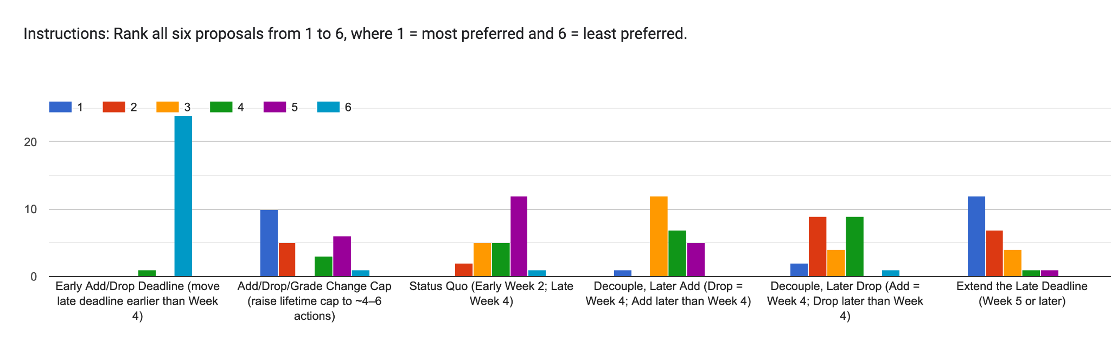

Highlighted Student Testimonies (Gathered October 15-Oct 25, 2025)
4th Year, Freshman Admit Student; Data Science & Political Science
“As a Data Science and Political Science student I can speak to my experience with courses and a extended late deadline can be extremely helpful to help students gauge their options. Sometimes you don't know what the workload of a course is like until you get deeper into the course. With the current add drop deadline you usually can't cycle through the first homework and project assignments and get your grades back to gauge your preparedness for a course in a lot of Data Science courses. Similarly in Political Science a lot of the courses are separated out into units and you don't get a good feel for a course until you've finished one unit and are a week or two into the second unit. Right now with the add drop deadline taking courses and gauging fits feels like a losing battle, you're enforced to make a decision before you have a fair amount of information to act on. It feels having to decide whether or not you want to buy a house after only seeing half the rooms. Week 5 or week 6 deadline would easily amend all of these issues.

Also a lot of people in Data Science/CS rely on waitlisting into their major classes. Extending the deadline would simply make the process of waitlisting less stressful as you have more of a window for others to drop the course you need to get into.

4th Year, Transfer Student; Political Science
“As a transfer student, I am uniquely limited in the amount of time I have at Berkeley, and thus feel added pressure to make the most of it. With only a few semesters to explore courses and fulfill my degrees requirements, every enrollment decision carries significant weight. The current add/drop structure forces students like me to finalize schedules before we’ve had a chance to experience enough of a course to consider if it aligns with our academic and professional goals. Moreover, some student organizations and clubs continue their recruitment processes past Week 4, which can greatly affect a student’s workload and availability.

Decoupling the add/drop deadlines would provide students with far more flexibility. By establishing an early add/drop period in Week 2 and extending the drop deadline beyond Week 4, this change would help transfer students, in particular, explore a broader range of classes and would help students better balance academic and extracurricular commitments. Overall, it would allow students to make more informed enrollment decisions based on a genuine understanding of their interests, goals, and schedules.”

2nd Year, Freshman Admit Student; English
“As a student currently petitioning to graduate a year early, I strongly believe the add/drop deadline should remain at Week 4 or later. I entered Cal as an out-of-state freshman with two semesters’ worth of transfer credits, and even with 30 units completed, I still had an overwhelmingly stressful start to my Fall 2025 semester. I had to intensively advocate to get into required courses, and ended up needing to drop classes, re-add, and enroll in new courses just two days before the late add/drop deadline. The only reason I secured the upper-division seminars I needed for my major was because of the time the late deadline provided; if it had been one week earlier, I would've been dropped from the class I absolutely needed to take this semester.

At a university as large as Cal, where students often face delayed graduation due to limited advising, poor enrollment priority, and overcrowded classes, a four-week shopping period is essential. Keeping the deadline at Week 4 ensures students have enough time to optimize their schedules, manage their workload, and protect their mental health.”

1st Year, Freshman Admit Student; Neuroscience
“At first, I thought it would be a good idea to move the add/drop deadline earlier so that more waitlisted students could get into classes. However, I now stand by the 4th week add/drop deadline. A shorter period of time will make it harder for students to gauge their performance in classes, potentially leading to students overestimating their ability to succeed in a class and thus not dropping when they would’ve dropped if the deadline was later. Because of this, I don’t think that moving the deadline up would benefit waitlisted students very much. I think an earlier deadline would harm students overall by creating unnecessary stress for students to decide on a set class schedule early on in the semester, when they are also busy with other activities such as club and internship applications.”

3rd Year, Freshman Admit Student; Political Science and Society & Environment
“Extending the late Add/Drop deadline to Week 5 (or later) would materially improve academic fit and compliance for international students. Full-time enrollment (12 units for visa status) is still in flux through Weeks 3–4 as waitlists move, labs/discussions finalize placements, and project or team-based courses reveal true workload and team dynamics after the first sprint. Clubs and research roles also complete onboarding around Weeks 3–5, reshaping weekly time commitments. A Week-5+ deadline lets international students secure a confirmed seat before dropping a placeholder course, reducing the risk of slipping below 12 units and triggering I-20/SEVIS complications. It also lowers the volume of exception petitions and emergency advising appointments that cluster when deadlines arrive before schedules stabilize. Reasonable guardrails, such as instructor consent for late Adds and a brief advising check for late Drops, can preserve instructional quality while keeping a necessary margin of safety. Rather than shifting timing risk onto students subject to visa rules, a modest extension shares that risk more fairly and supports both status protection and thoughtful course selection.”

Current Official Stance of the ASUC Office of Academic Affairs
Based on the data collected in the survey and our office’s current understanding of student opinion, the Office of Academic Affairs (AAVP) does not currently find any ability to support an earlier Add/Drop deadline. Such a change would limit students’ ability to make informed decisions about their coursework and could disproportionately affect those balancing rigorous academic, employment, and extracurricular commitments. We believe any modifications to the Add/Drop policy must reflect the lived experiences of students and uphold UC Berkeley’s core values of flexibility, exploration, and academic discovery. The AAVP Office remains committed to working collaboratively with the Council of Undergraduate Deans, the Office of the Vice Provost for Undergraduate Education, faculty, and campus administration to develop a solution that benefits all stakeholders—but most importantly, serves the best interests of UC Berkeley students.

Citations/References
Brice, Anne. “UC Berkeley Named Top Public School in the Country by ‘U.S. News.’” UC Berkeley News, 22 September 2025, news.berkeley.edu/2025/09/22/uc-berkeley-named-top-public-school-in-the-country-by-us-news/.
Chang, Casey. “UC Berkeley Considers Earlier Class Add/Drop Deadline; ASUC Expresses Concerns.” The Daily Californian, 9 October 2025, www.dailycal.org/news/campus/academics/uc-berkeley-considers-earlier-class-add-drop-deadline-asuc-expresses-concerns/article_64eeca08-3437-4d16-83d3-22684d00b8e4.html.
Edelstein, Wendy. “New drop/add deadline goes into effect for fall semester.” *Berkeleyan*, University of California, Berkeley, 12 April 2005, newsarchive.berkeley.edu/news/berkeleyan/2005/04/12_drop_add.shtml.
Tang, Amber. “UC Berkeley Aims to Enroll Students on Waitlists with Updated Add/Drop Deadline.” The Daily Californian, 11 September 2018, www.dailycal.org/archives/uc-berkeley-aims-to-enroll-students-on-waitlists-with-updated-add-drop-deadline/article_4e63e7f9-aa33-51b0-92b1-48a1b13941c2.html](http://www.dailycal.org/archives/uc-berkeley-aims-to-enroll-students-on-waitlists-with-updated-add-drop-deadline/article_4e63e7f9-aa33-51b0-92b1-48a1b13941c2.html

Appendix D
Add/Drop Student Survey Link: https://qualtricsxmj3jgjst8q.qualtrics.com/jfe/form/SV_dhaa0bRmqkfFNxI

Appendix E
MEMORANDUM
Campus-Wide Student Survey on the Add/Drop Deadline Results and Analysis

ASUC Office of Academic Affairs
Jennifer, ASUC Academic Affairs Vice President (aavp@asuc.org)
Dylan Lucks, Chief of Staff (aavpchief@asuc.org)
Jonathan Franco, Chief of Staff (aavpchief@asuc.org)

To: Academic Senate, Undergraduate Council Feb. 4, 2026

Overview and Executive Summary
This memo presents findings from a comprehensive survey of UC Berkeley undergraduate students regarding the proposal to move the add/drop deadline earlier in the semester. The survey was conducted between December 2025 and January 2026, accumulating responses from a broad range of students due to the advertising and community organization efforts of the Office of Academic Affairs. Methods of survey distribution included flyers posted around campus, including in the general assignment classroom buildings, dining halls, libraries, and student study spaces, publicization through RSOs and Senator Offices, and publicization through select courses.
Overall, the results of the survey show overwhelming student opposition to the proposed earlier add/drop deadline, with the most vulnerable student populations facing disproportionate harm.
As the UC Berkeley campus considers this policy change, it is essential that student voices not only be consulted but also actively guide any changes to the add/drop deadline. Undergraduate students are directly affected by this policy, as course enrollment decisions intersect with a wide range of personal, academic, and financial considerations. Beyond the classroom, students often balance part-time employment, research commitments, housing or transportation challenges, financial aid requirements, and responsibilities to family or community. These factors shape when and how students make final decisions about their course schedules.
Listening to and prioritizing student perspectives ensures that policy decisions reflect the realities of the undergraduate experience—not only the administrative or logistical efficiencies of the enrollment system. Meaningful student input is therefore necessary to ensure that changes to the add/drop timeline uphold Berkeley’s commitment to equity, inclusion, and student success.

Respondent Demographics
The campus-wide survey, hosted by the ASUC Office of Academic Affairs, was released on December 3, 2025, and closed on January 31, 2026. It has a total of 247 responses.
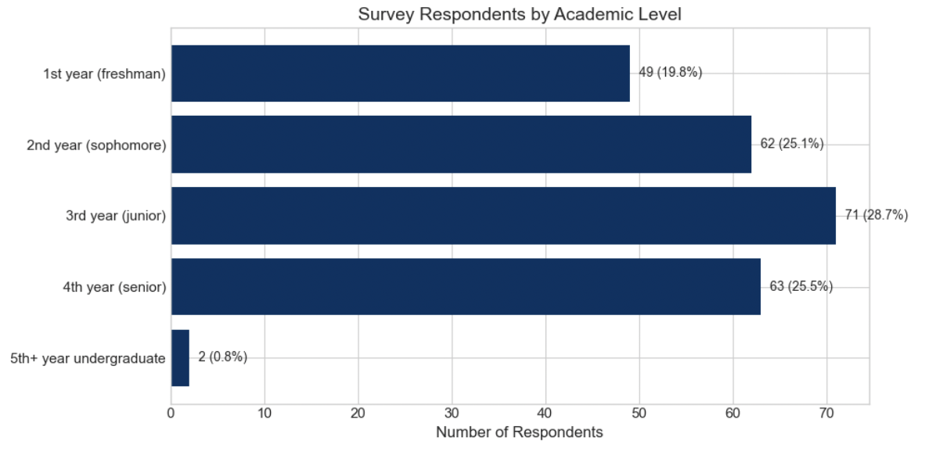
Figure 1.1 Survey Respondents by Academic Level
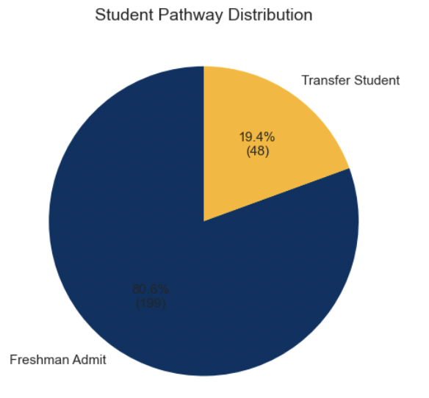
The survey captured responses across all class years, with upperclassmen (juniors and seniors), students who have the most experience navigating Berkeley's add/drop system, comprising 54% of respondents.

Furthermore, the survey respondents mirror the actual student body. Transfer students make up about 20% of Berkeley's undergraduate population, and they represent 19.4% of survey respondents (Figure 1.2).
Figure 1.2 Student Pathway Distribution

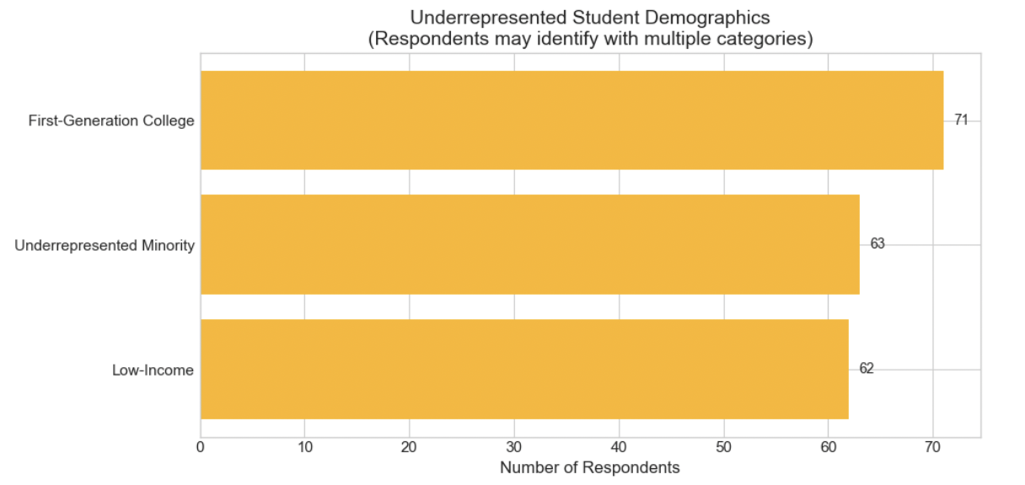
Figure 1.3 Underrepresented Student Demographics

Finally, it is important to acknowledge that first-generation, low-income, and underrepresented minority students often face additional barriers in navigating academic systems. Amongst the 247 survey respondents, 116 respondents (47.0%) identified as belonging to at least one underrepresented group. Policy changes to the add/drop system should consider this population’s additional challenges and needs.

Current Add/Drop Behavior
Understanding current add/drop usage patterns provides essential context for evaluating the proposed policy change. Survey data (Figure 2.1) reveal that 159 students (64.4%) dropped at least one class in the last two semesters, demonstrating the wide impact of the add/drop system and illustrating how any changes to the system generate significant policy concern.

This is further demonstrated by the students' distribution of when they drop courses: a significant number of drops occur in Week 3, Week 4, and after (Figures 2.2). Moving the deadline earlier would affect students who need this time to assess course fit, receive grades on early assessments, and make informed decisions.

Furthermore, while 64.4% of respondents dropped at least one class in the last two semesters, 71.3% respondents dropped only 0-1 classes total during that period (Figure 2.1). This pattern demonstrates thoughtful, selective decision-making throughout the student body rather than systemic abuse of the add/drop period.

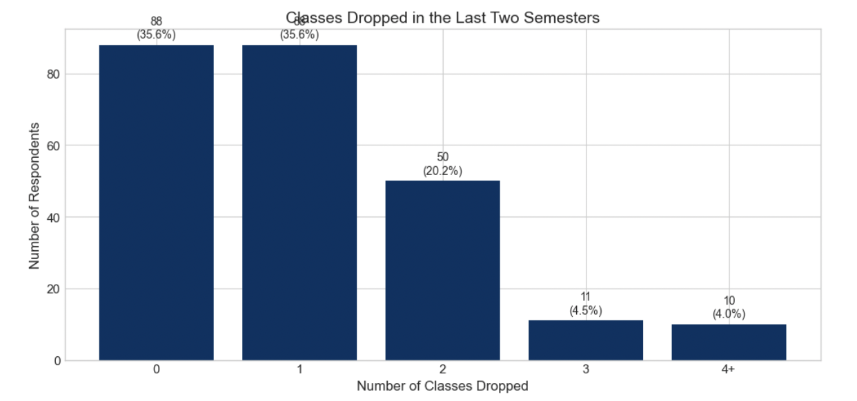
Figure 2.1 Classes Dropped in the Last Two Semesters

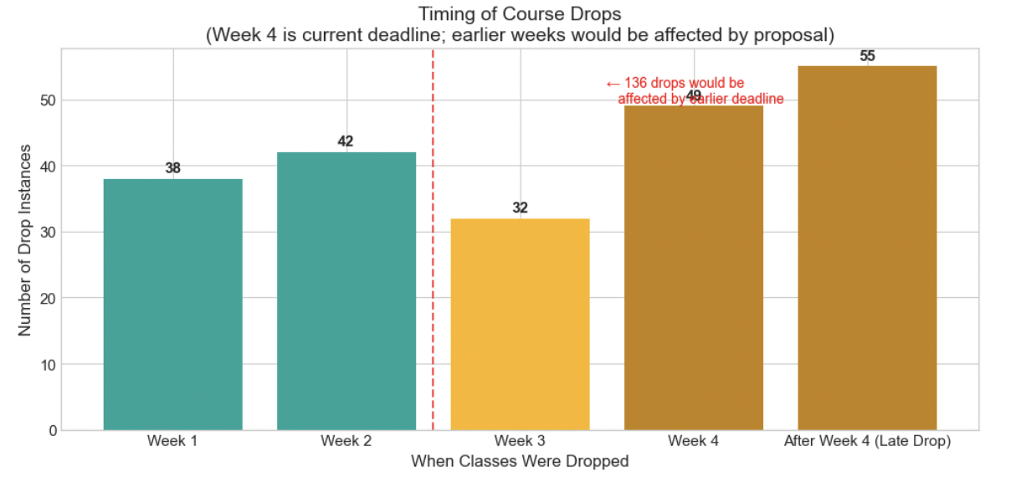
Figure 2.2 Timing of Course drops

The survey also asks respondents for the reasons why they are dropping courses after Week 3 (the new proposed deadline). Data (Figure 2.3) reveals that the top answers, unexpected workload and performance concerns, require time spent in the courses to become apparent.

These are not issues students can assess from a syllabus or course description alone. Understanding whether a course's workload is manageable requires experiencing the actual pace of assignments, the difficulty of problem sets, and the time commitment for readings and projects. Similarly, performance concerns only emerge after students receive graded feedback, which often does not occur until the 4th or 5th week of the semester.

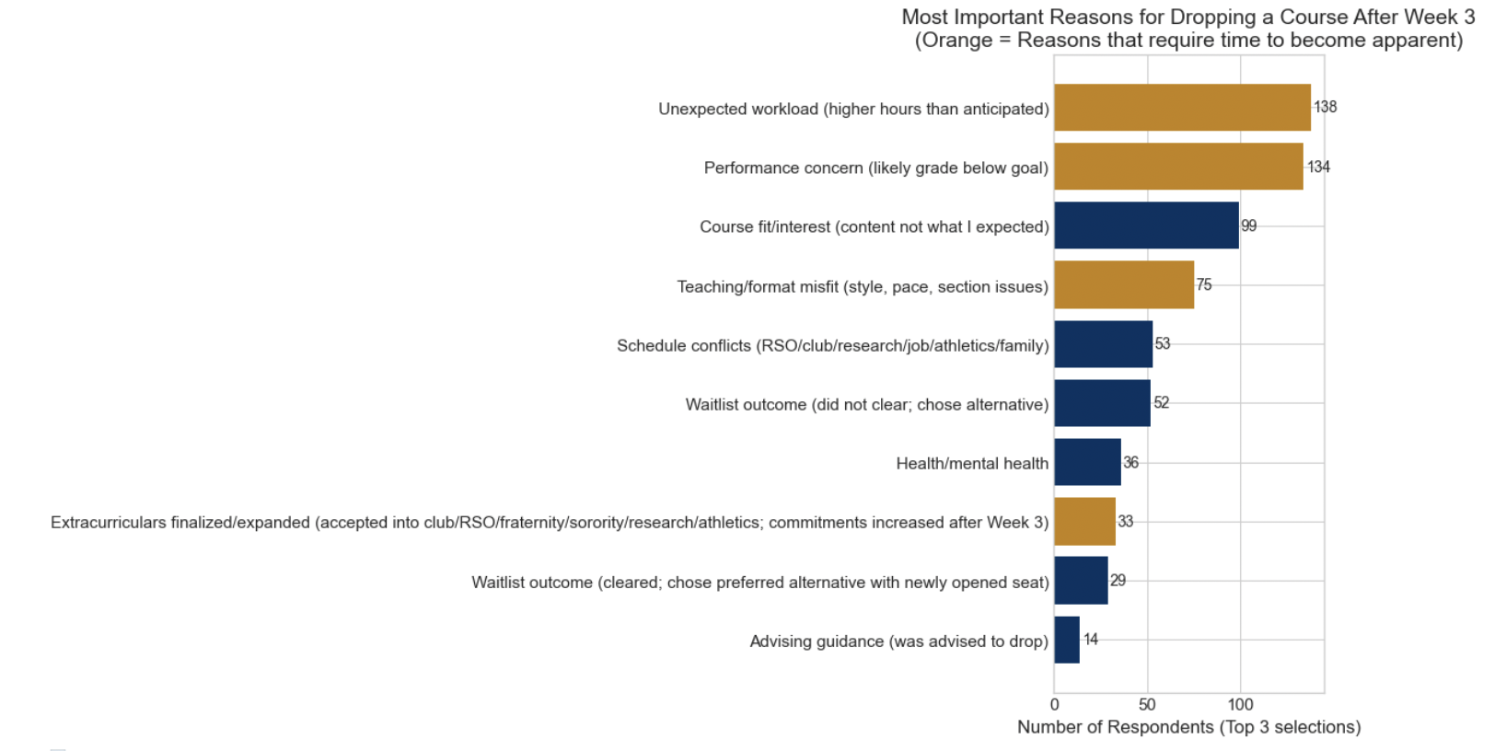
Figure 2.3 Most important reasons for dropping a course after Week 3

Waitlists
One argument the Office of Academic Affairs considered in our first memo was that an earlier add/drop deadline would enable waitlists to resolve more efficiently and reduce the number of students attending classes unofficially into weeks three or four of the term. The survey data (Figure 3.1) confirms this is a legitimate concern: 38.1% of respondents (94 students) attended classes for three or more weeks while waitlisted and did not ultimately gain admission.
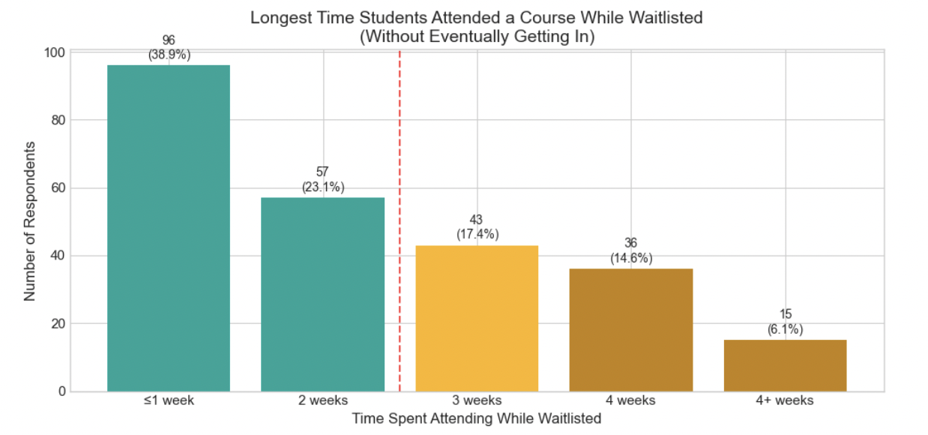
Figure 3.1 Longest Time Student Attended a Course While Waitlisted

However, the question remains whether an earlier add/drop deadline would effectively address this issue, and the survey data suggest it would not.

When asked directly about the impact of an earlier deadline, only 16 students (6.5%) identified "waste less time on waitlisted classes" as a potential benefit (Figure 3.2). This impact is further compounded when you consider the proportion of students who clear the waitlist in a preferred course (29 students) and the students who do not clear the waitlist and have to find an alternative (52 students) (Figure 3.3). An earlier deadline may inadvertently harm the students it aims to help. The 94 students (38.1%) who attended classes for three or more weeks while waitlisted would have a reduced window to identify and enroll in alternative courses if the deadline were moved earlier. These students require additional flexibility to adjust their schedules when waitlists do not clear in their favor, not less time to do so.
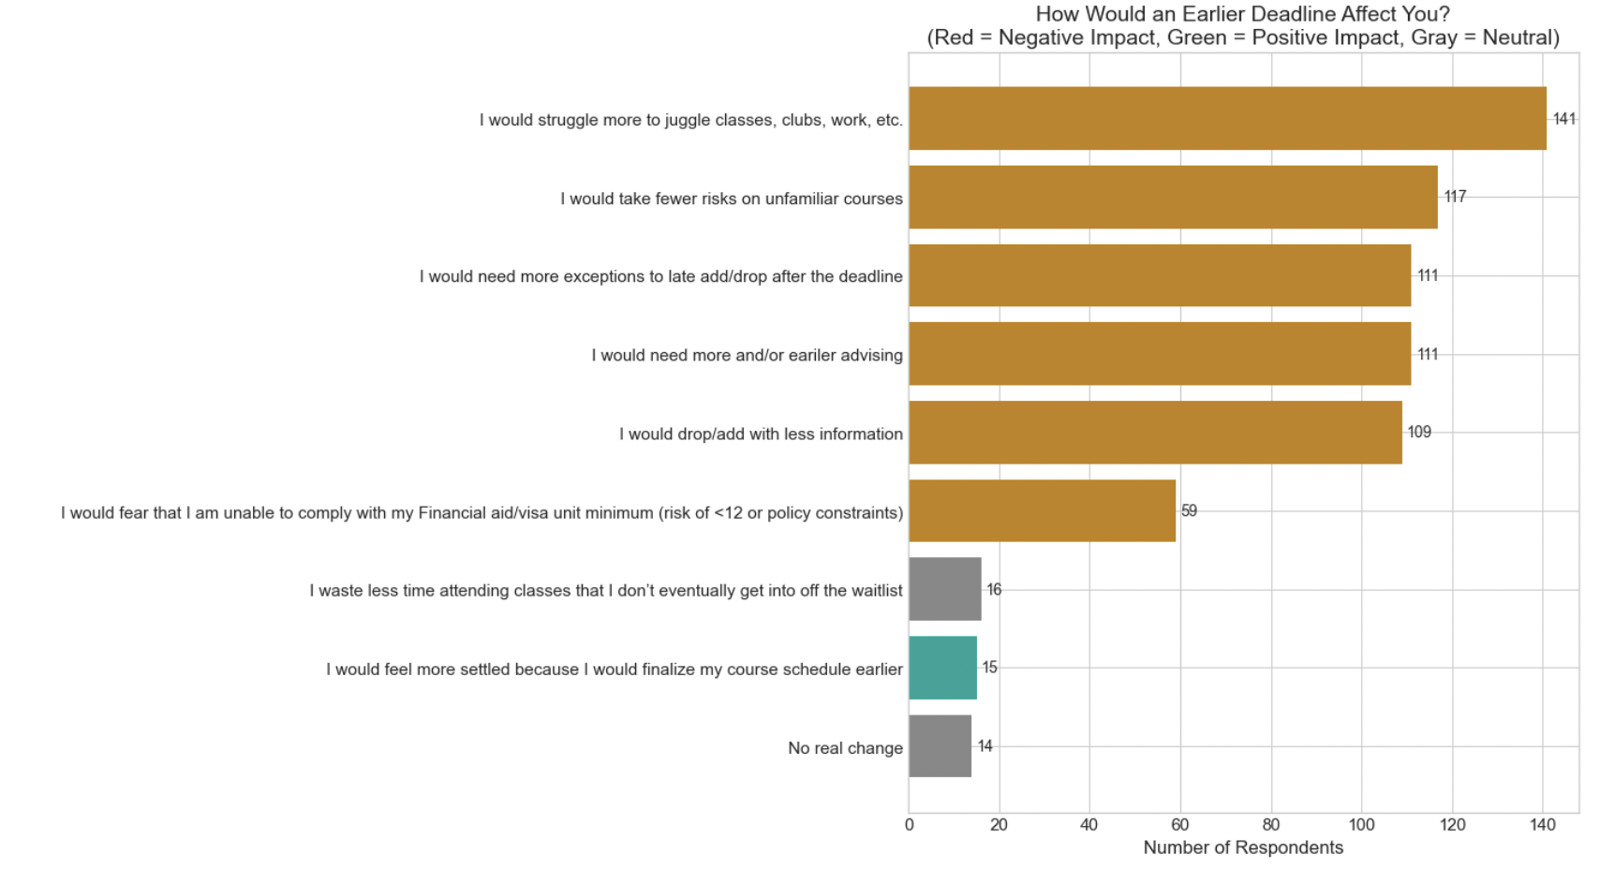
Figure 3.2 How would an earlier deadline affect you?

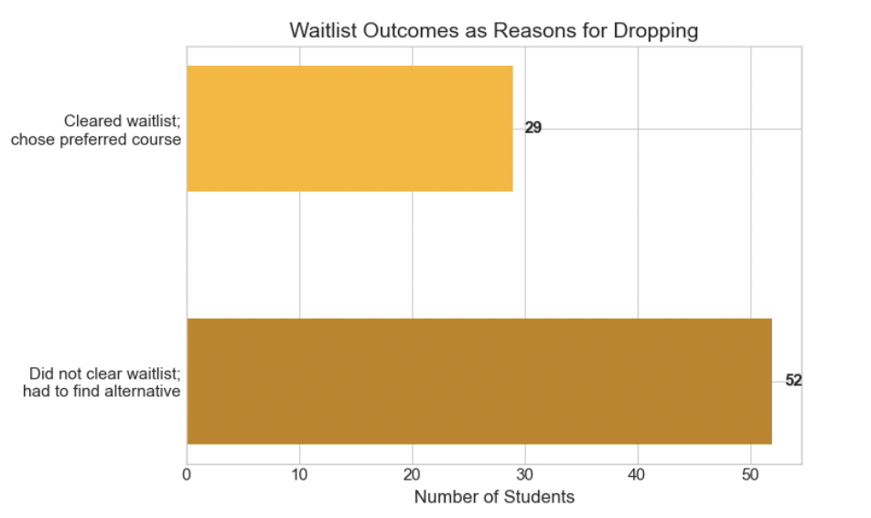
Figure 3.3 Waitlist Outcomes as Reasons for Dropping
Instead, students demonstrated a clear preference for improved waitlist information systems over deadline modifications. When asked what would help them make earlier decisions (Figure 3.4 Figure 3.5), 136 students (55.1%) selected "clearer waitlist estimates/dashboards," compared to only 16 students (6.5%) who viewed the earlier deadline as beneficial for managing waitlists (Figure 3.4 & Figure 3.2 ). Students favor information tools over policy restrictions.

This analysis suggests that improving waitlist transparency and information systems would more effectively address student concerns than reducing the add/drop window.
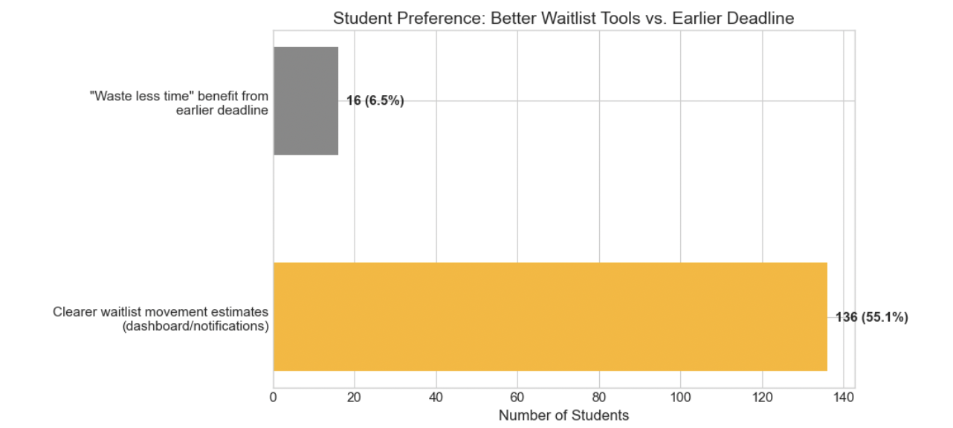
Figure 3.4 Student Preference: Better Waitlist Tools vs. Earlier Deadline
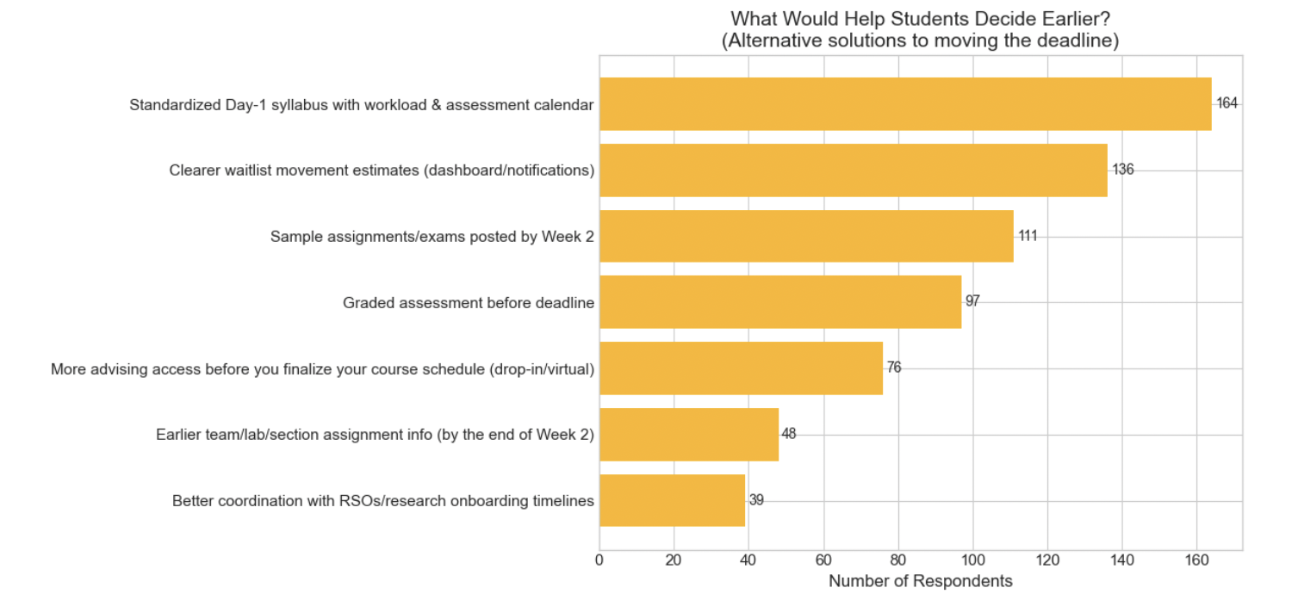
Figure 3.5 What would help students decide earlier?

Impact of an Earlier Add/Drop Deadline
The most critical section of our survey asked students directly how an earlier add/drop deadline would affect them (Figure 3.2/4.1).

Figure 4.1 How would an earlier deadline affect you?

The responses show that overwhelmingly, students report a negative impact of an earlier add drop deadline, including struggling more with juggling classes, clubs, and work, taking fewer risks on unfamiliar courses, needing more exceptions to the late add/drop, needing more advising, and adding/dropping with less information.

Of all 247 respondents, 231 or 93.5% of students reported at least one negative impact. Only 12 students, or 4.9% reports they would not see any real change (Figure 4.2)
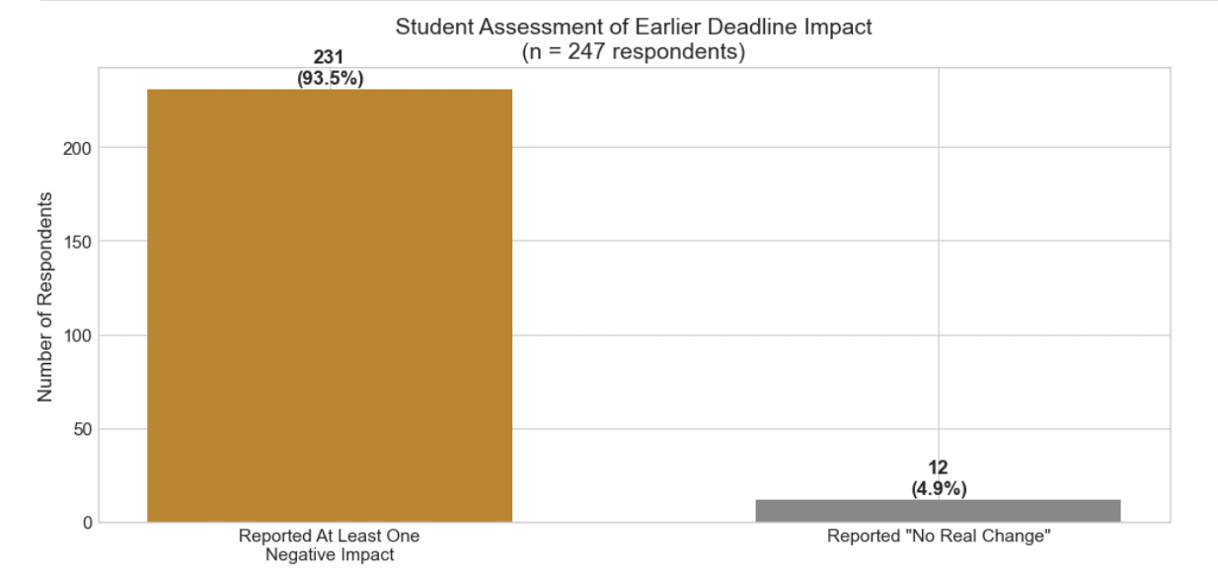
Figure 4.2 Student Assessment of Earlier Deadline Impact

When we take into account the increased impact of such a policy change on transfer students and underrepresented minority groups, we see similar numbers (Figure 4.3).

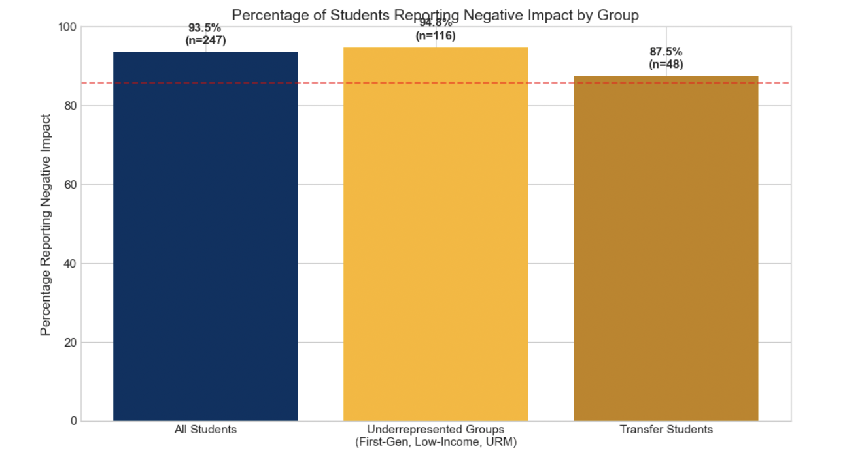
Figure 4.3 Percentage of Students Reporting Negative Impact by Group

Finally, changing the add/drop deadline would hold particular risks for students who depend on maintaining minimum unit loads for financial aid or visa compliance. This overwhelmingly impacts our most vulnerable student communities on campus. 40.5% of underrepresented students specifically cited concerns about financial aid and visa compliance. These students cannot afford to drop below 12 units, making add/drop flexibility critical for their ability to adjust courses while maintaining minimum enrollment requirements.
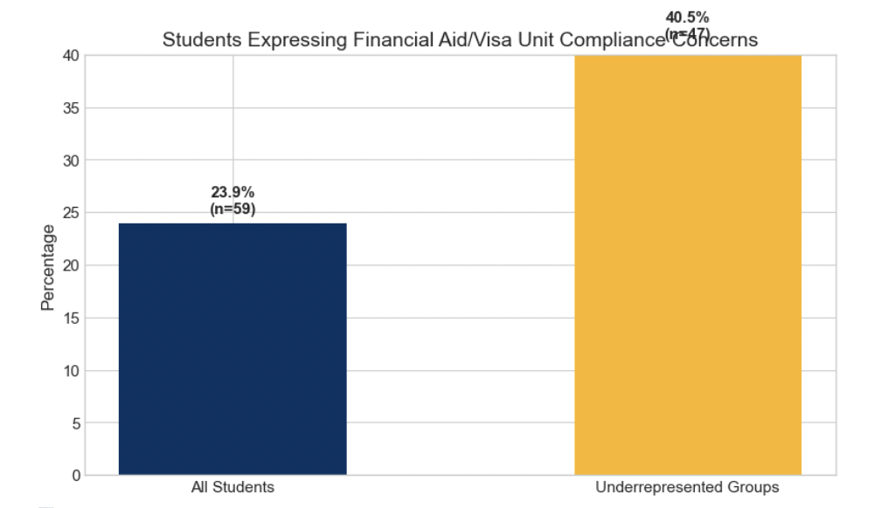
Figure 4.4 Student Expressing Financial Aid/Visa Unit Compliance Concerns

Official Stance of the ASUC Office of Academic Affairs
Based on the data collected in the survey and our office’s current understanding of student opinion, the Office of Academic Affairs (AAVP) still does not find any ability to support an earlier Add/Drop deadline. Such a change would limit students’ ability to make informed decisions about their coursework and could disproportionately affect underrepresented groups on campus and those balancing rigorous academic, employment, and extracurricular commitments. We believe any modifications to the Add/Drop policy must reflect the lived experiences of students and uphold UC Berkeley’s core values of flexibility, exploration, and academic discovery. The AAVP Office remains committed to working collaboratively with the Council of Undergraduate Deans, the Office of the Vice Provost for Undergraduate Education, faculty, and campus administration to develop a solution that benefits all stakeholders—but most importantly, serves the best interests of UC Berkeley students.

